# Azure Logic Apps

## LAB 1: Create Azure Logic App

**Lab Overview**

In this lab you will create a simple Azure Logic App that will be triggered by new Tweets and send those Tweets to an email address.

**Create Azure Logic App from Template**

1. Launch a browser and navigate to https://portal.azure.com. Once prompted, login with your Microsoft Azure credentials. If prompted, choose whether your account is an organization account or just a Microsoft Account.
2. Click on +NEW, then click on Web + Mobile, and click on Logic App.

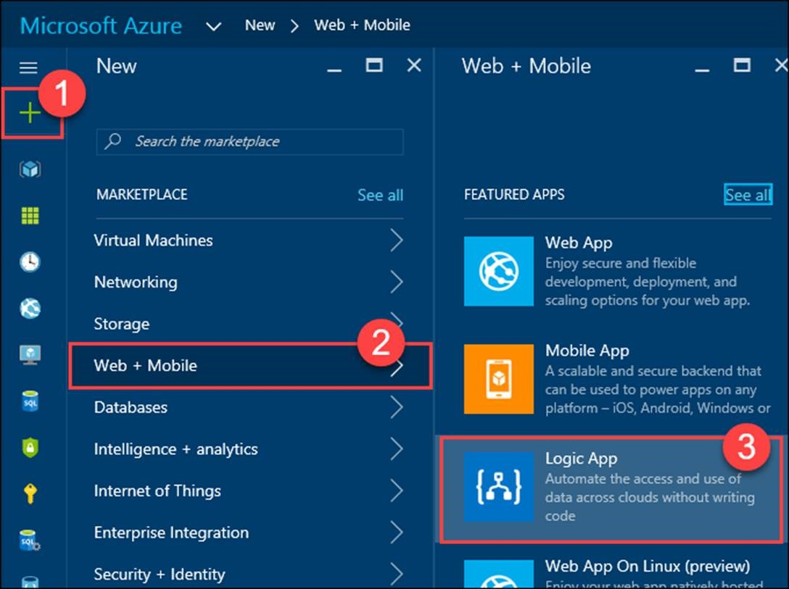

1. On the Create logic app blade, enter the following value:

Name: TwitterLogicApp

Resource group: TwitterLogicAppRG

Location: Choose the Azure Location / Region closest to you

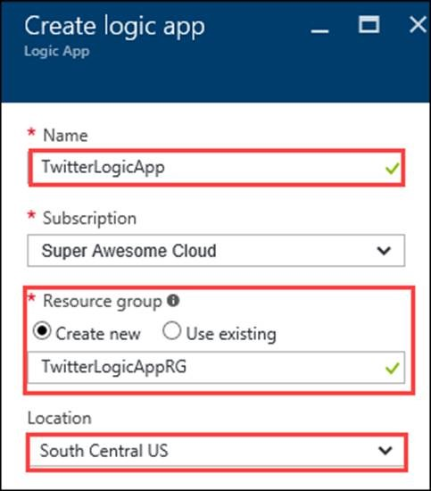

1. Click Create
2. The new Logic App will take a minute to provision.
3. Once the Logic App has finished being provisioned, click on Resource groups, then click on the TwitterLogicAppRG resource group, and click on the TwitterLogicApp logic app.

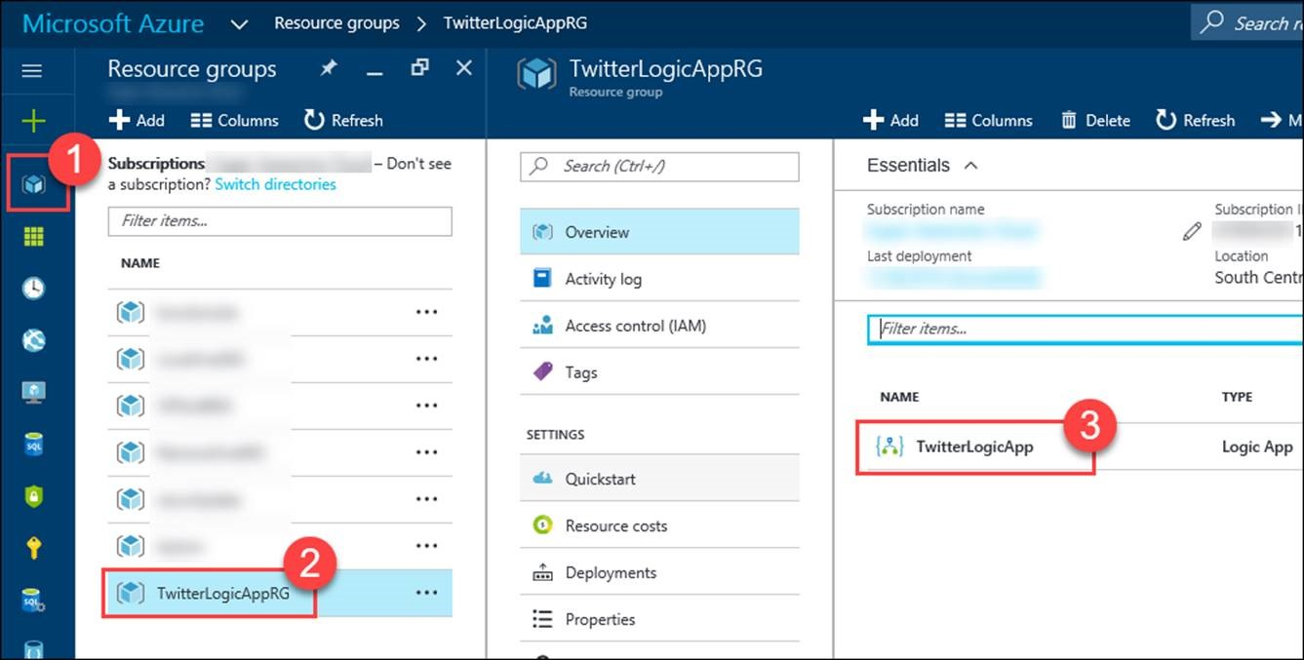

1. In the Logic Apps Designer, scroll down and click on the Email yourself new tweets about a certain keyword via Outlook

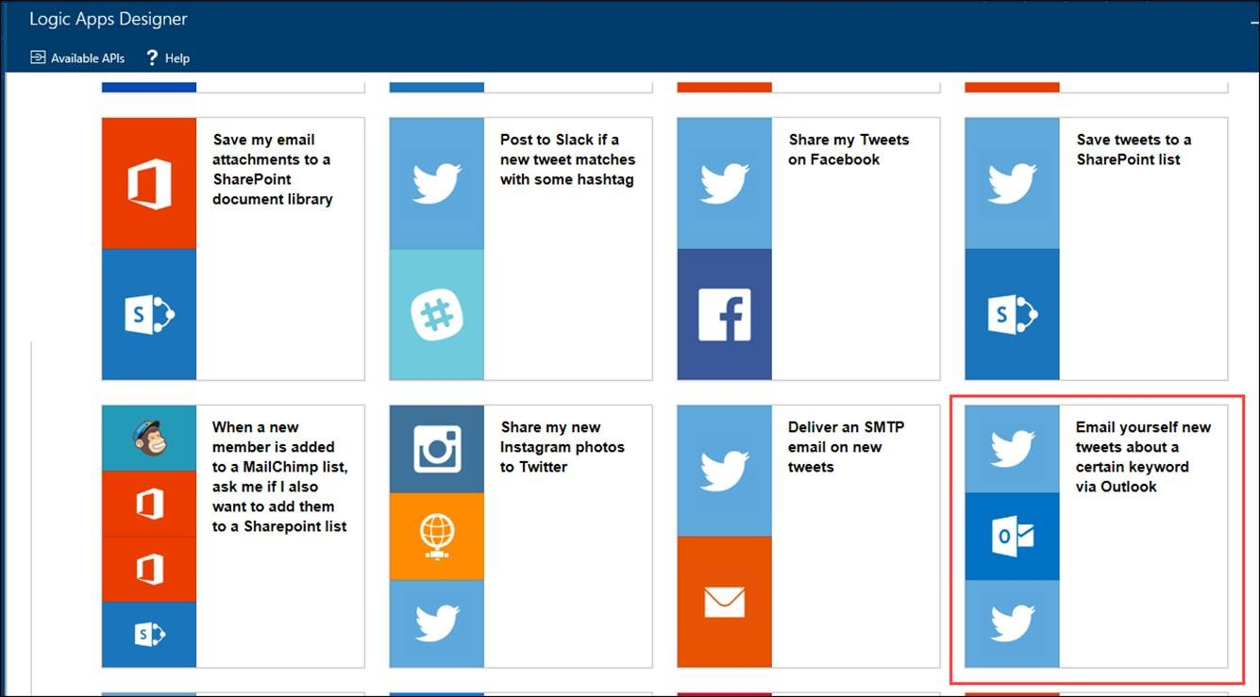

1. Click the Use this template button.

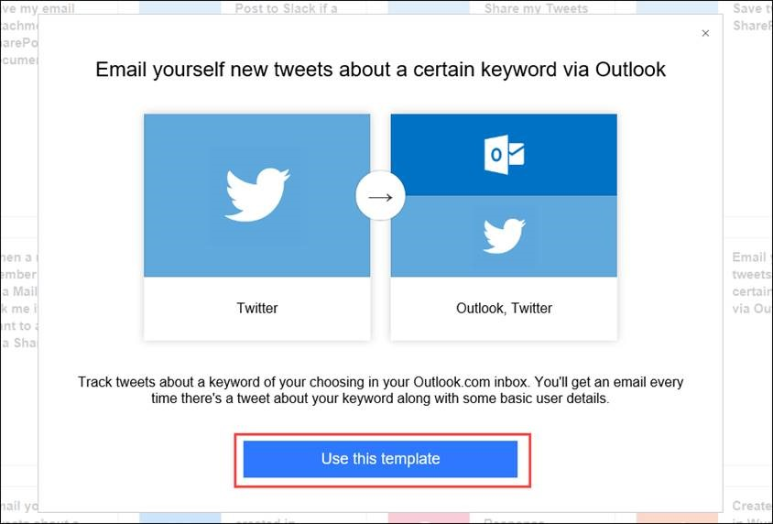

1. Click the Sign in button for Twitter and login with your Twitter Account.

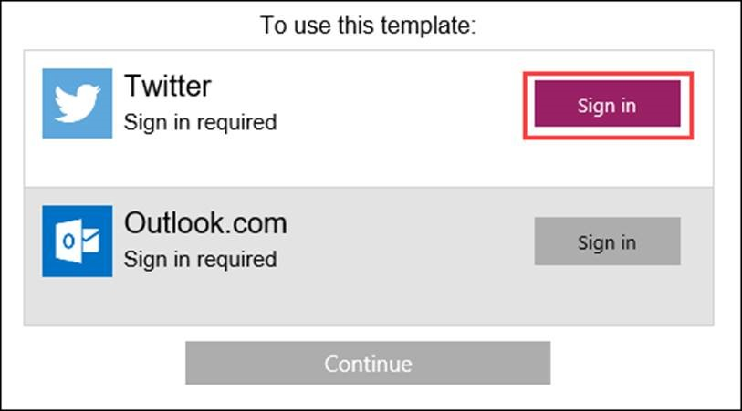

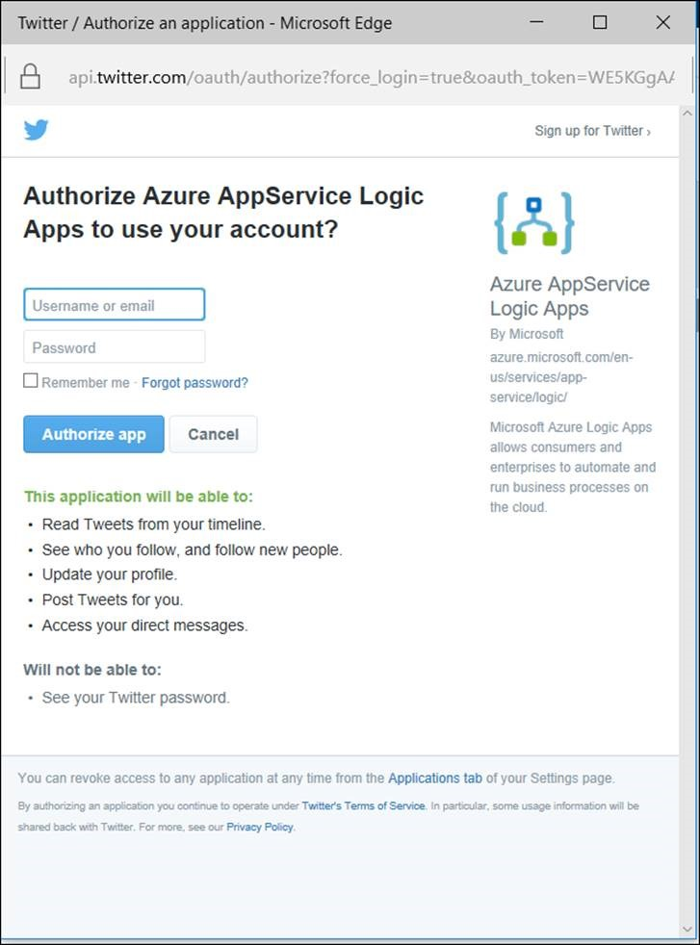

1. Click the Sign in button for Outlook.com and login with your Outlook.com email account.

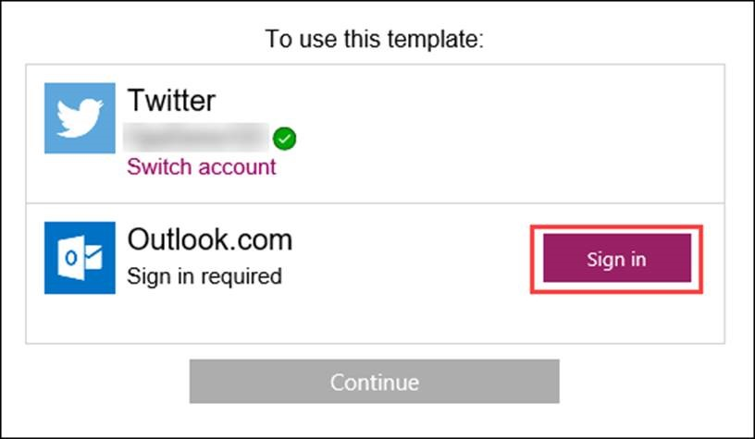

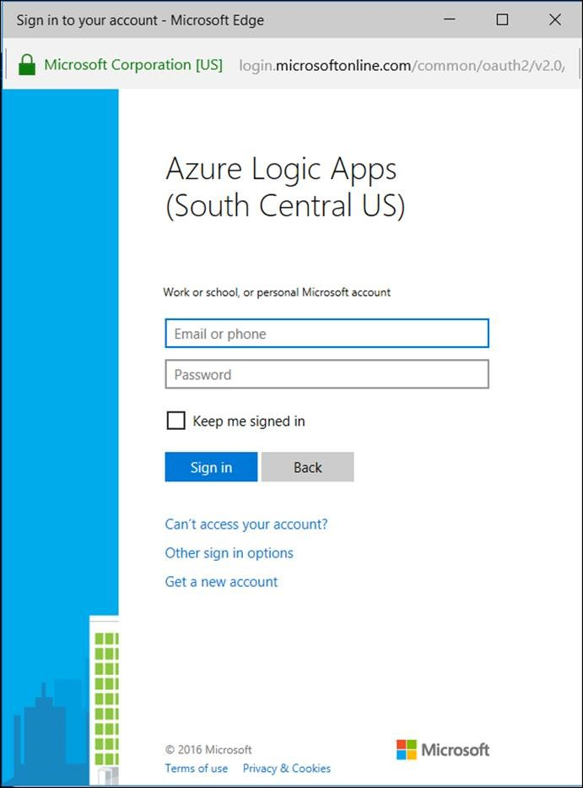

1. Click Yes to accept the Permissions.

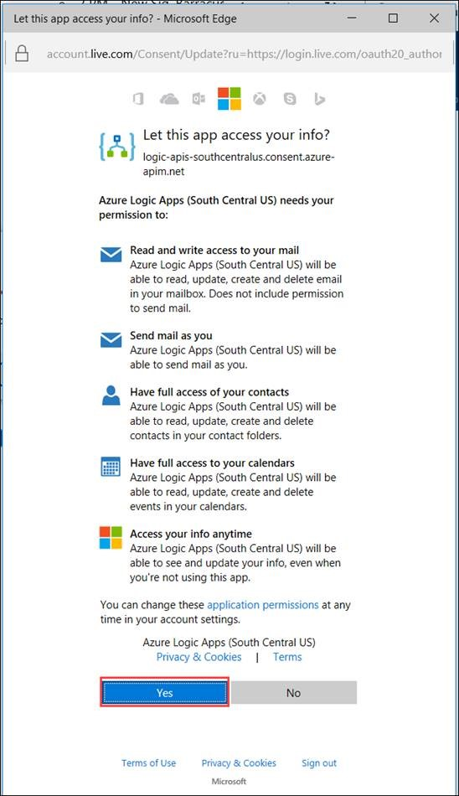

1. Click Continue.

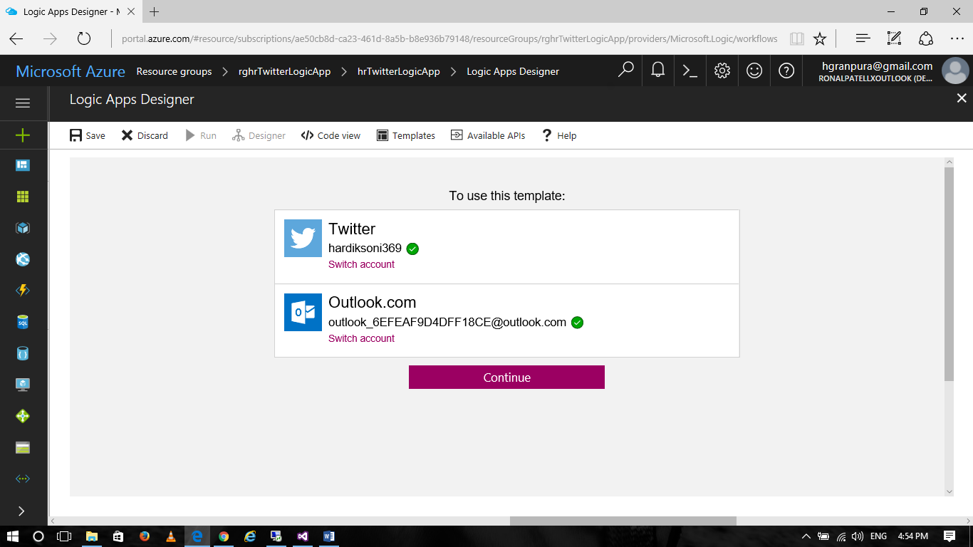

1. On the “When a new tweet appears” connector, type in #LogicApps into the Search text field. This will search for tweets with that hashtag.

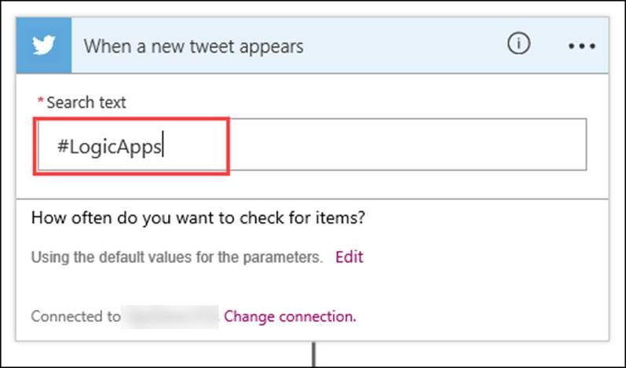

1. On the Send email connector, enter an Email Address to send the notifications to in the To field.

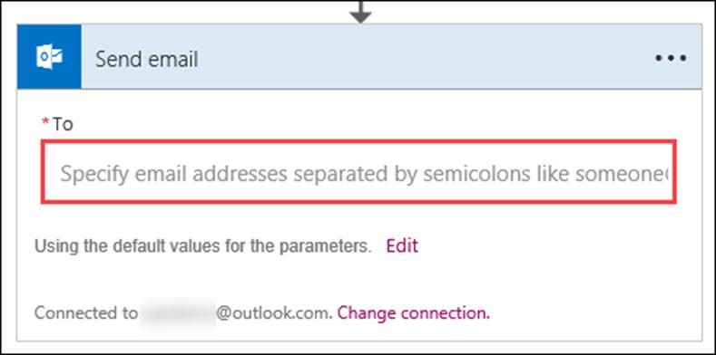

1. This “To” email address can be the Outlook.com email that was created earlier, or any other email address. Just be sure to use an email address that you can see the Inbox for.
2. Click on Edit so the default values can be changed.

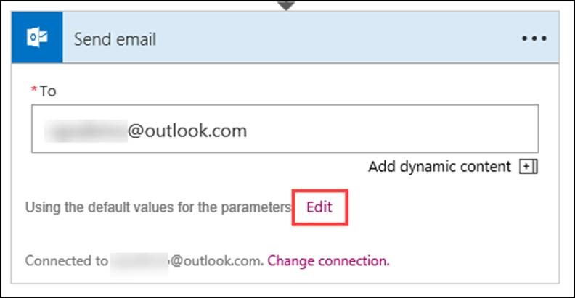

1. Look at the Subject and Body to see how they will be filled in with values retrieved from the tweet received from the Trigger.

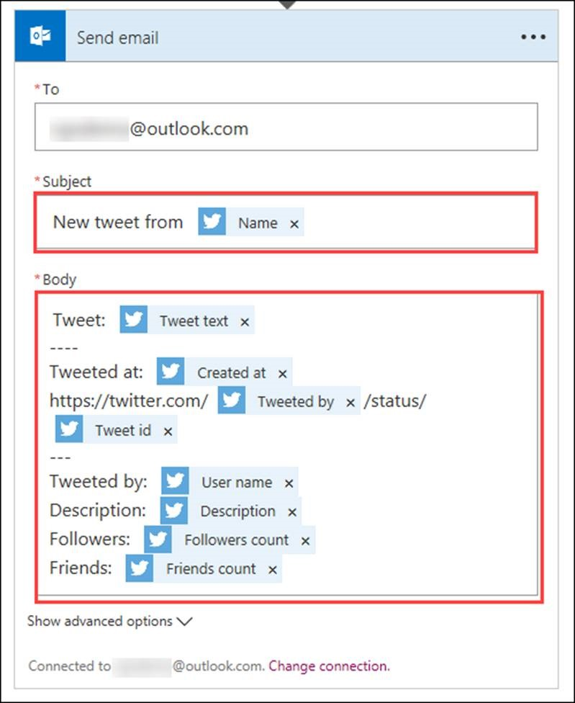

1. Edit the Body by removing the “Friends: {friends count}” line at the bottom of the email body, and replace it with “Location: {location}” to include the location at the bottom of the email body.

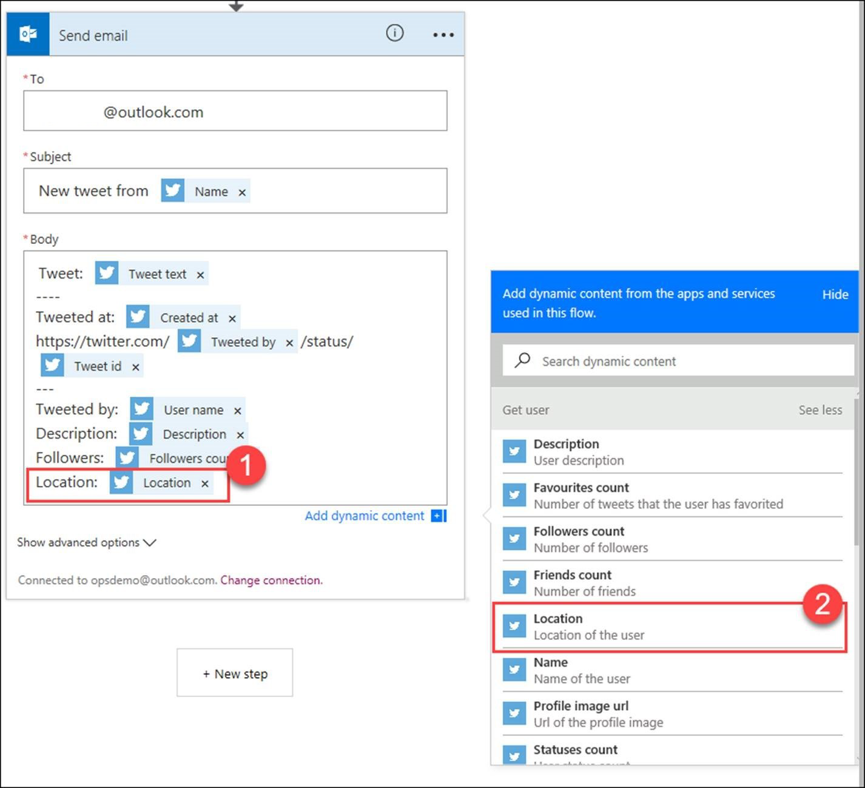

1. On the Logic App Designer blade, click the Save button.

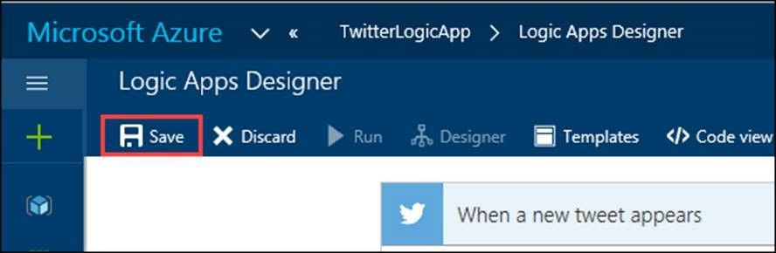

1. To start the Logic Apps, click the Run button.



1. To see that the Logic App works, try posting a tweet that uses the #LogicApps hashtag on Twitter.

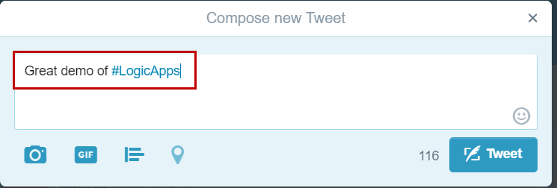

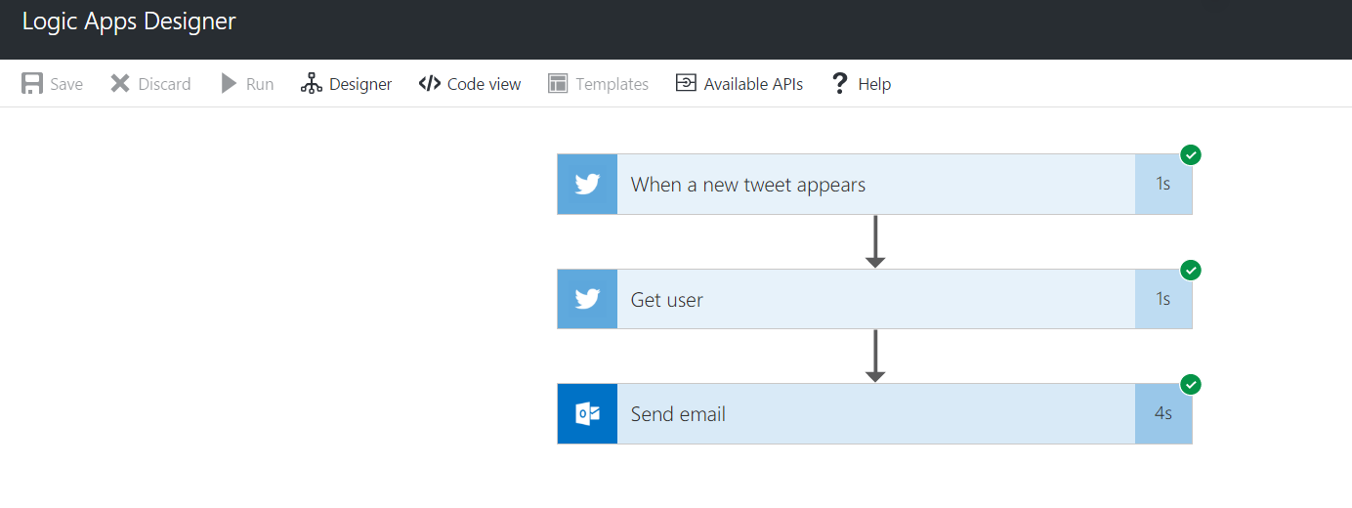

1. Then access your Outlook.com email address Inbox to see the email message with the tweet.

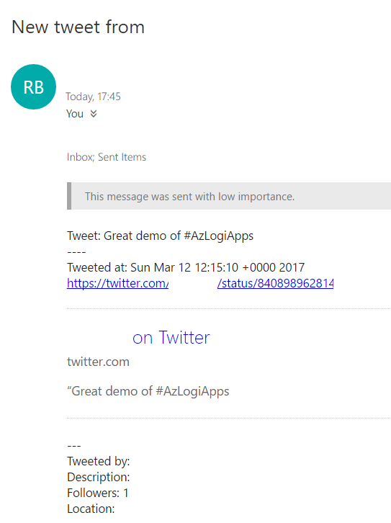

It may take a minute or two for the email to show up in the Inbox.

## Lab Summary

In this lab you created a simple Azure Logic App that will be triggered by new Tweets and send those Tweets to an email address.